

**A Project on**

# BBA.CA Department Management System

**For partial fulfillment of**

Bachelor of Business Administration

(Computer Application)

**Submitted by**

**271 Anas Asgar Gharade**

**275 Ayman Sufiyan Kokate**

**273 Affan Nadeem Dawre**

**Under the Guidance**

**Of**

**Dr. AlifiyaJahagirdar**

In the

Academic Year

2023-2024

­­­

**Index**

|  |
| --- |
| **Introduction** |
| **Existing System** |
| **Proposed System** |
| **Feasibility Study :**   1. Technical Feasibility 2. Economical Feasibility 3. Operation Feasibility |
| **System Design :**   1. DFD (Data Flow Diagram) 2. Zero Level 3. First Level 4. Second Level |
| **Input / Output** |
| **Conclusion** |
| **Future Enhancement** |
| **Software Requirements** |
| **Hardware Requirements** |
| **Bibliography** |

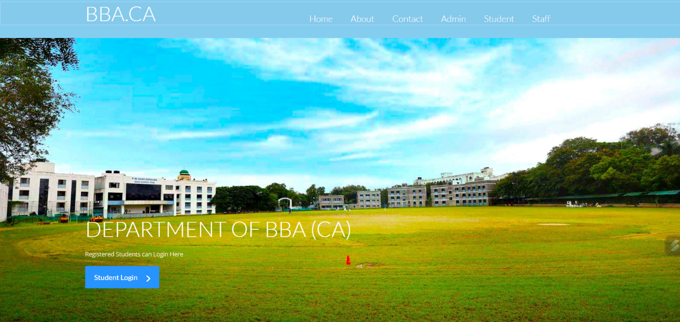

**Introduction**

A Department Management System (DMS) is a comprehensive software solution designed to streamline and optimize the various administrative and operational processes within an organization's departments. This system aims to enhance efficiency, collaboration, and overall productivity by automating routine tasks, facilitating communication, and providing real-time access to relevant information. DMS is particularly beneficial in large organizations where multiple departments function independently yet need to coordinate seamlessly for the overall success of the business.

User Access Control DMS typically offers role-based access control, ensuring that only authorized personnel can access specific information and perform certain tasks. This helps maintain data security and confidentiality.

**Existing System:  
A Student Management System (SMS) is a software application that helps educational institutions manage various aspects of student-related information and processes. The existing system may vary based on the specific needs and technologies adopted by an institution. However, I can outline some common features and components that are typically found in student management systems:**

**Student Information Management:**

**Basic personal information (name, address, contact details).Academic details (courses enrolled, classes attended, grades, etc.).Attendance records.Emergency contact information.**

**Admissions and Registration:Application processing for new students.Registration for courses and classes.Generation of student IDs.**

**Course Management:**

* + **Course details (description, prerequisites, credit hours).Assignment and examination schedules.Grading and evaluation.**

EXISTING SYSTEM:

System Analysis is a detailed study of the various operations performed by a system and their

relationships within and outside of the system. Here the key question is- what all problems exist in the

present system? What must be done to solve the problem? Analysis begins when a user or manager begins a

study of the program using existing system.

During analysis, data collected on the various files, decision points and transactions handled by the

present system. The commonly used tools in the system are Data Flow Diagram, interviews, etc. Training,

experience and common sense are required for collection of relevant information needed to develop the

system. A good analysis model should provide not only the mechanisms of problem understanding but also

the frame work of the solution. Thus, it should be studied thoroughly by collecting data about the system.

Then the proposed system should be analyzed thoroughly in accordance with the needs

EXISTING SYSTEM:

System Analysis is a detailed study of the various operations performed by a system and their

relationships within and outside of the system. Here the key question is- what all problems exist in the

present system? What must be done to solve the problem? Analysis begins when a user or manager begins a

study of the program using existing system.

During analysis, data collected on the various files, decision points and transactions handled by the

present system. The commonly used tools in the system are Data Flow Diagram, interviews, etc. Training,

experience and common sense are required for collection of relevant information needed to develop the

system. A good analysis model should provide not only the mechanisms of problem understanding but also

the frame work of the solution. Thus, it should be studied thoroughly by collecting data about the system.

Then the proposed system should be analyzed thoroughly in accordance with the needs

System Analysis is a detailed study of the various operations performed by a system and their

relationships within and outside of the system. Here the key question is- what all problems exist in the

present system? What must be done to solve the problem? Analysis begins when a user or manager begins a

study of the program using existing system

EXISTING SYSTEM:

System Analysis is a detailed study of the various operations performed by a system and their

relationships within and outside of the system. Here the key question is- what all problems exist in the

present system? What must be done to solve the problem? Analysis begins when a user or manager begins a

study of the program using existing system.

During analysis, data collected on the various files, decision points and transactions handled by the

present system. The commonly used tools in the system are Data Flow Diagram, interviews, etc. Training,

experience and common sense are required for collection of relevant information needed to develop the

system. A good analysis model should provide not only the mechanisms of problem understanding but also

the frame work of the solution. Thus, it should be studied thoroughly by collecting data about the system.

Then the proposed system should be analyzed thoroughly in accordance with the needs.

**Feasibility study**

The feasibility study is useful to evaluate the cost and benefit of the system requested. The feasibility study tries to anticipate future scenarios of software development. There are three major aspects in the Feasibility Study.

* Technical Feasibility
* Operation Feasibility
* Economical Feasibility

**TECHNICAL FEASIBILITY:**

The technical issue usually raised during the feasibility stage of the investigation includes the following:Does the necessary technology exist to do what is suggested?Do the proposed equipment’s have the technical capacity to hold the data required to use the new system?Will the proposed system provide adequate response to inquiries, regardless of the number or location of users?Can the system be upgraded if developed?Are there technical guarantees of accuracy, reliability, ease of access and data security?

**OPERATIONAL FEASIBILITY:**

Proposed projects are beneficial only if they can be turned out into information systems, which will meet the organization’s operating requirements. Operational feasibility aspects of the project are to be taken as an important part of the project implementation.

Some of the important issues raised are to test the operational feasibility of a project includes the following: –Is there sufficient support for the management from the users?Will the system be used and work properly if it is being developed and implemented?Will there be any resistance from the user that will undermine the possible application benefits?This system is targeted to be in accordance with the above-mentioned issues. Beforehand, the management issues and user requirements have been taken into consideration. So there is no question of resistance from the users that can undermine the possible application benefits.The well-planned design would ensure the optimal utilization of the computer resources and would help in the improvement of performance status.

**ECONOMIC FEASIBILITY:**

A system can be developed technically and that will be used if installed must still be a good investment for the organization. In the economical feasibility, the development cost in creating the system is evaluated against the ultimate benefit derived from the new systems. Financial benefits must equal or exceed the costs. The system is economically feasible. It does not require any additional hardware or software.

**System Design**

**DFD (Data Flow Diagram**

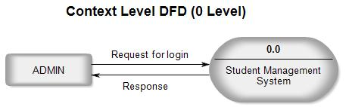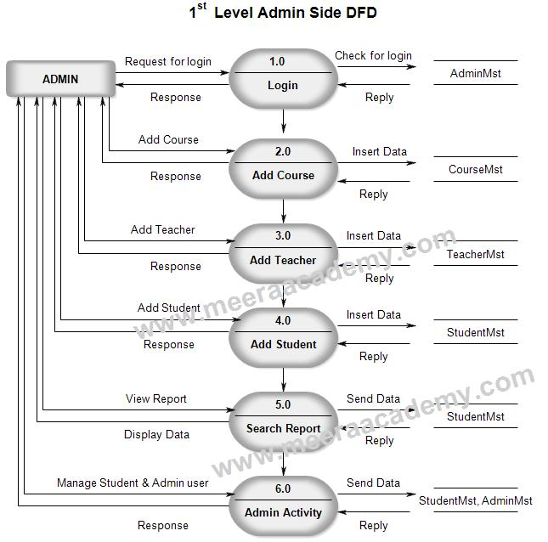

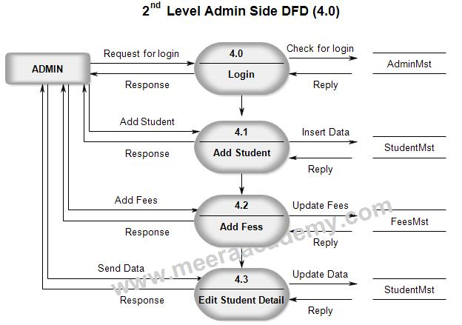

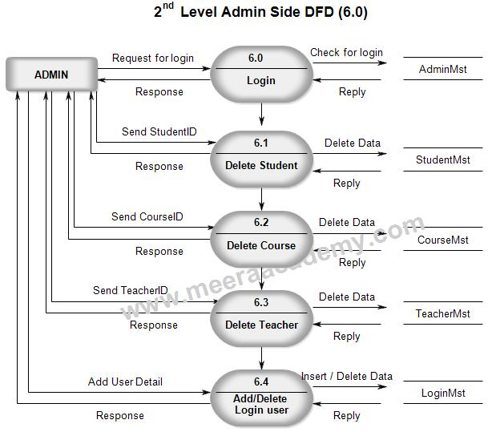

**Input / Output Screen**

**This is first page for Student login**

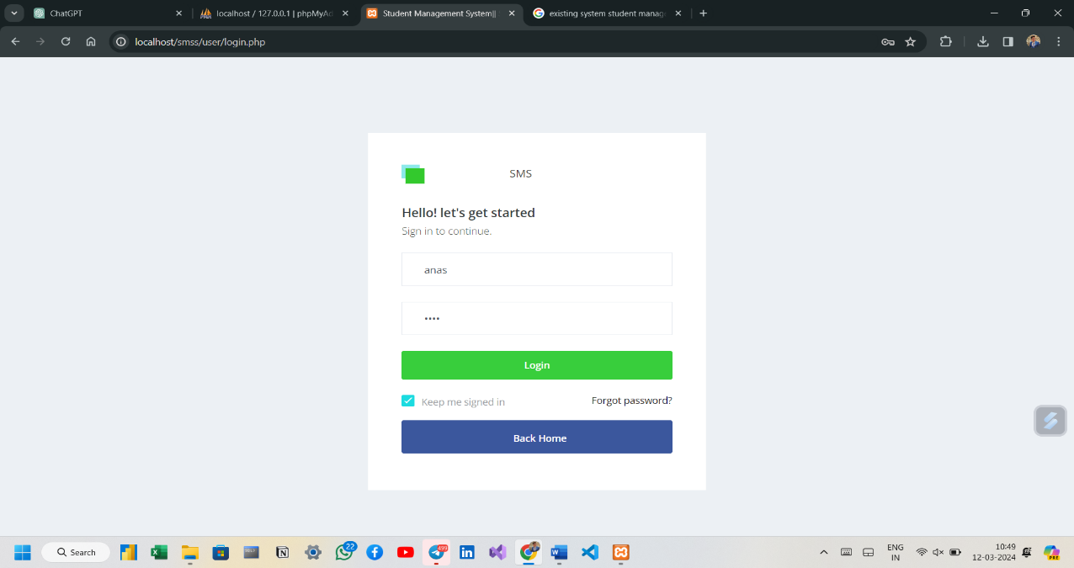

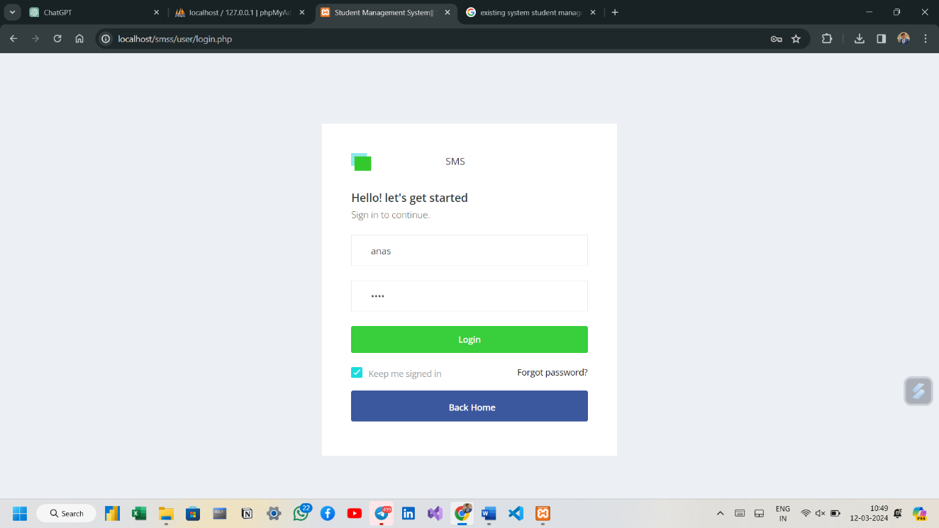**Login your username and password you have created your account and click log in.**

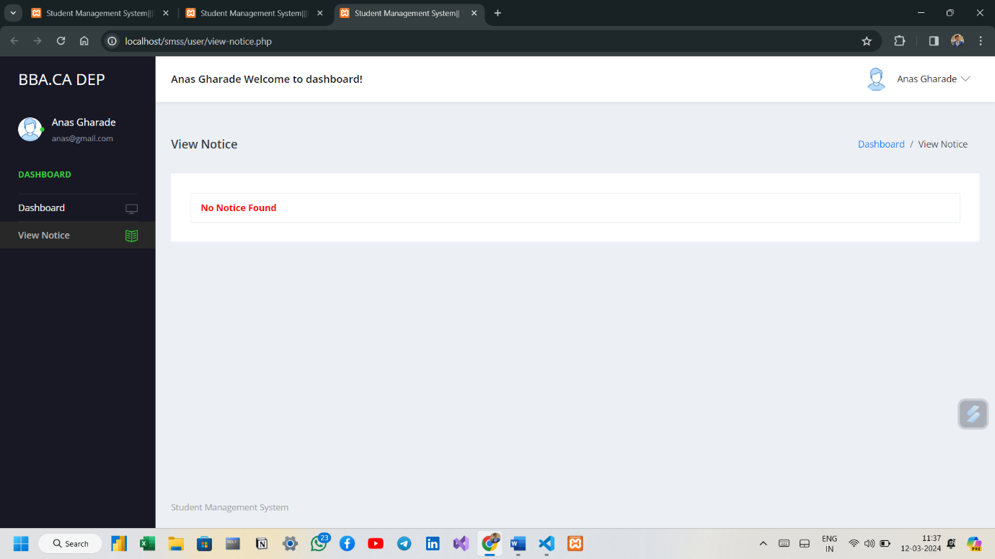**If your information in validate then you will be proceed to Notice page, which have notice showing on Admin Panel and button to ‘See Notice’.**

**In navigation section you have about section where there is information about the BBA.CA Department.**

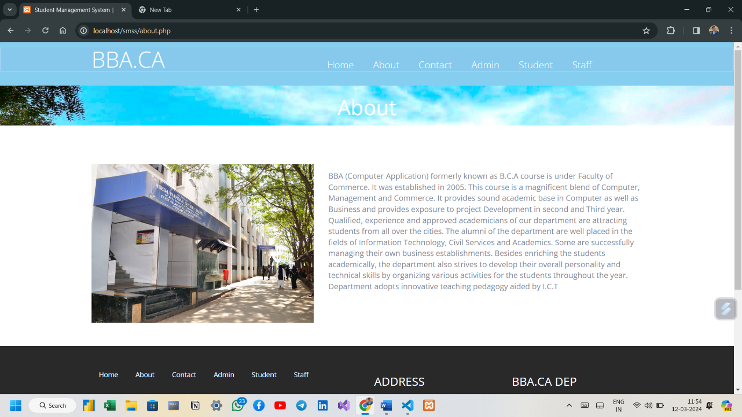

**After clicking on ‘Staff’ button you will be Show Staff page as shown in the picture.**

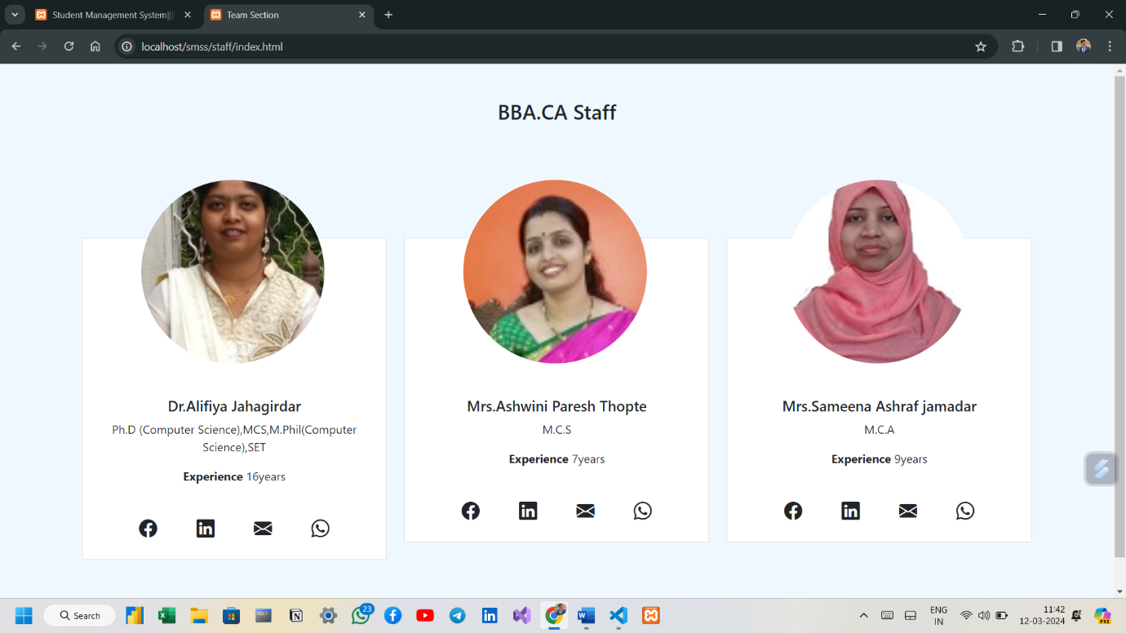

**Now This Is a Admin Login Page ,Where Admin Can Login And Add Students Details**

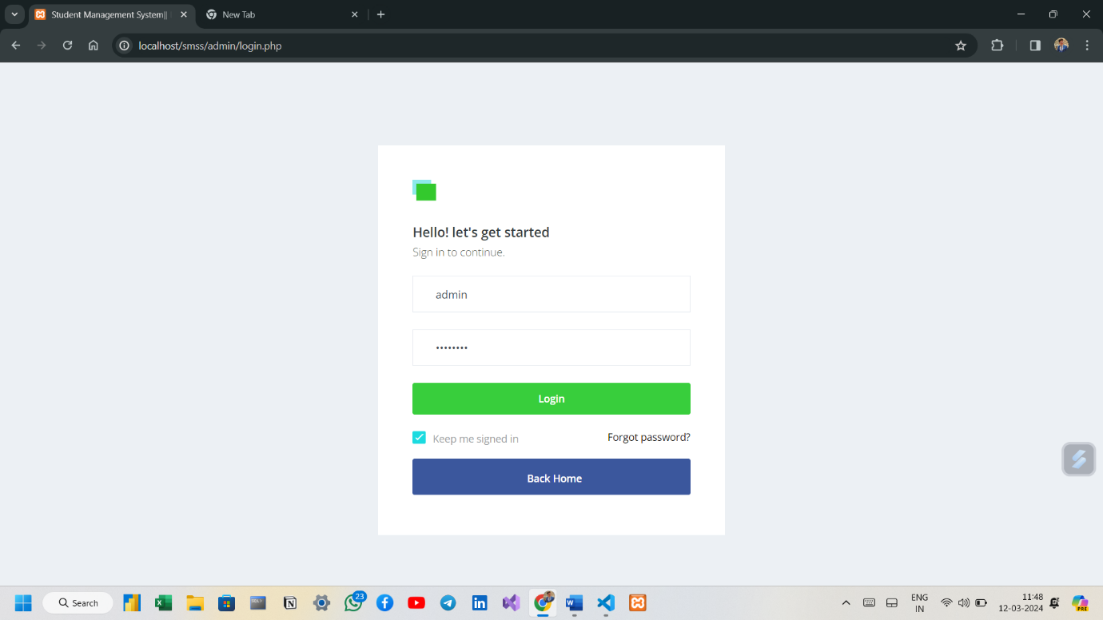

**After clicking On Login Here Is a dashboard Of Admin**

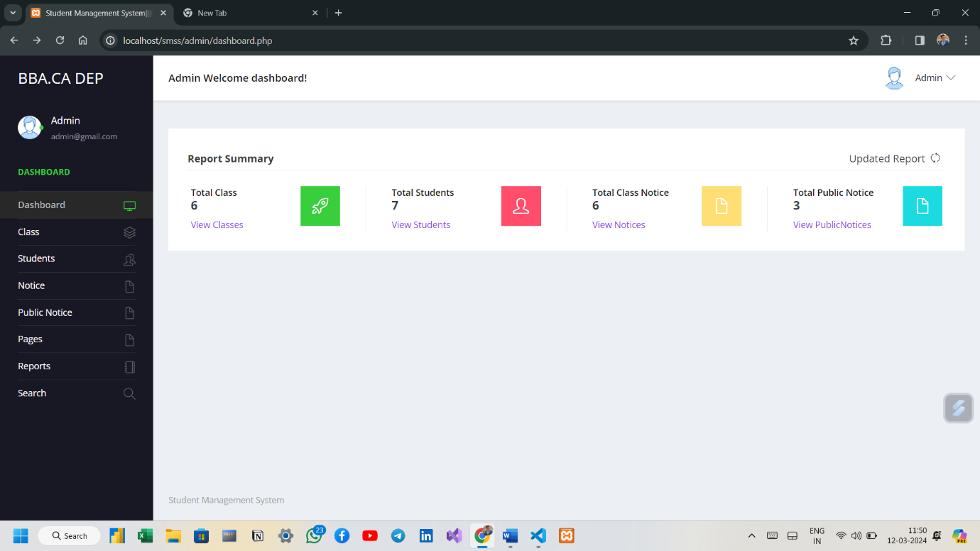

**This is the database for admin form.**

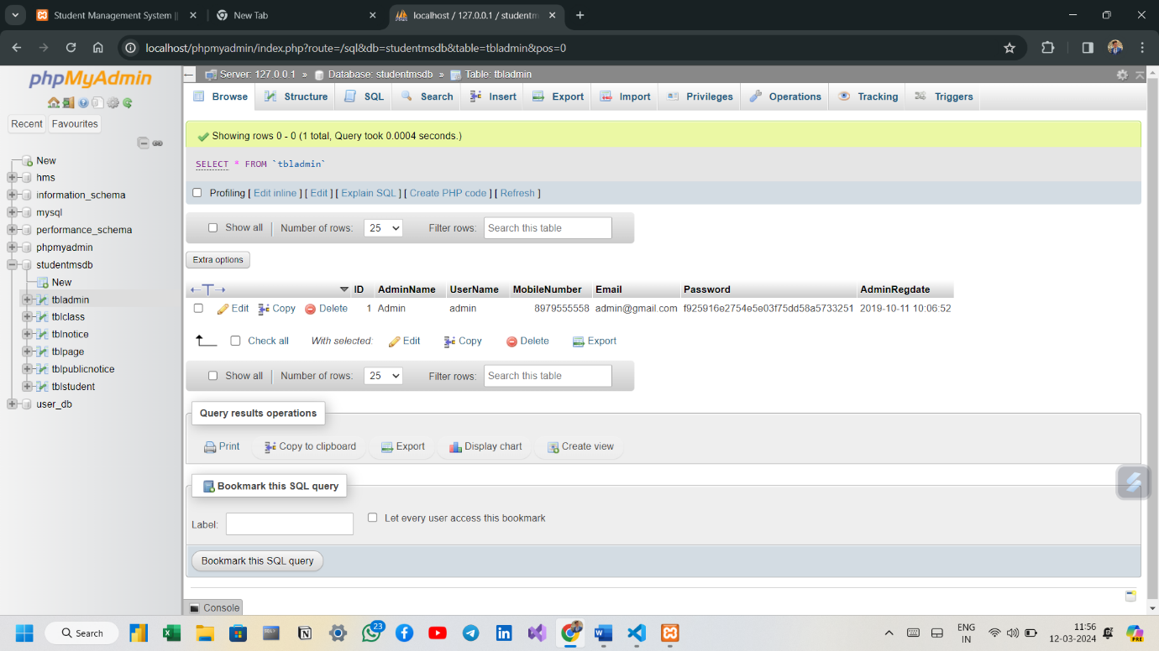

**This is the database for the Notice**

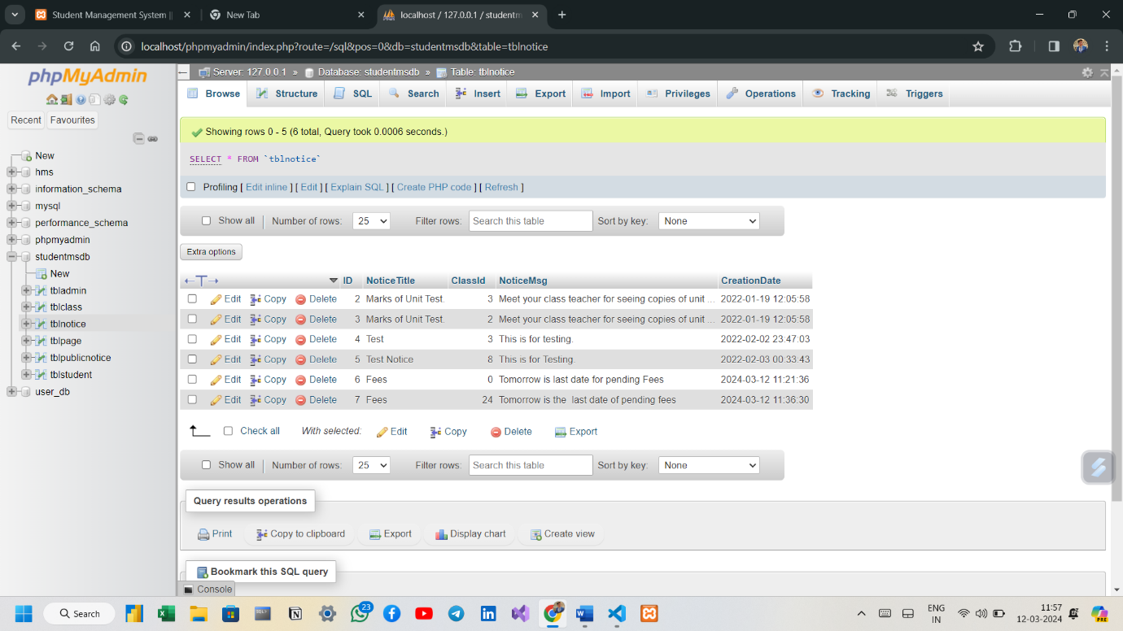

**This database For StudentRecords**

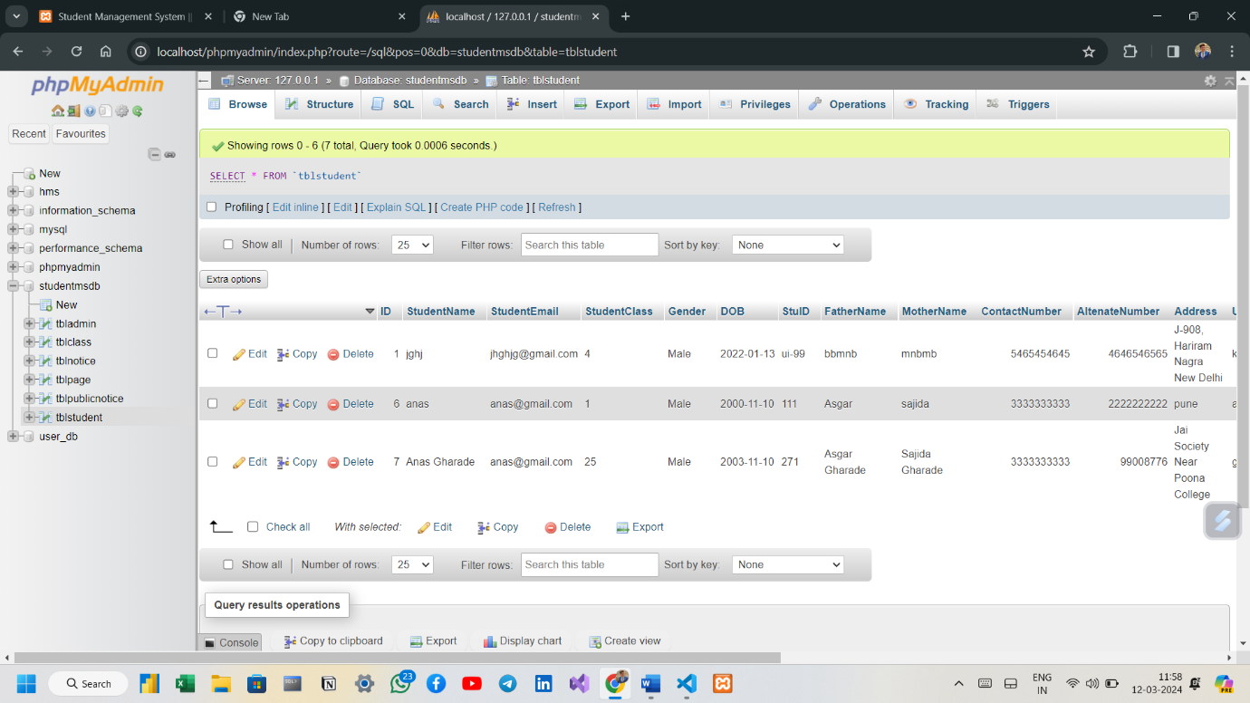

**This Database Is For PublicNotice**

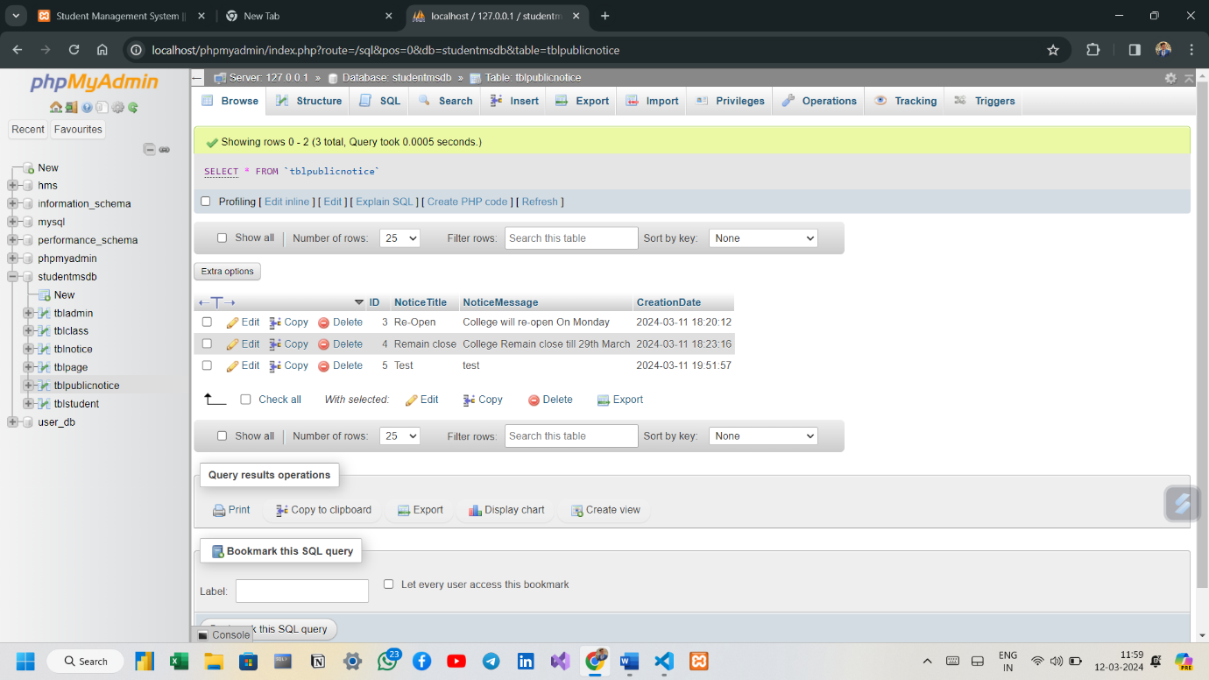

**Conclusion**

In this project we study the gym managment system. It is developed in visual basic and the database has been built in PL/SQL only, keeping in mind the specifications of the system, Apart from MS-Access the organization have also implemented other database software like Oracle or SQL. For elaborating the system we have used simple data flow diagrams.

**Overall the project teaches us the essential skills like:**

* Using system analysis and design techniques like data flow diagram in designing the system.
* Understanding programming logic and language along with utilities like reports, forms, queries etc. in Visual Basic and PL/SQL.

**Future Enhancement:**

The project has a very vast scope in future. The project can be implemented on intranet in future. Project can be updated in near future as and when requirement for the same arises, as it is very flexible in terms of expansion. With the proposed software of database Space Manager ready and fully functional the client is now able to manage and hence run the entire work in a much better, accurate and error free manner. The following are the future scope for the project.

* Discontinue of particular student eliminate potential attendance.
* Bar code Reader based attendance system
* Individual Attendance system with photo usinglogin

**Bibliography**

1. **Book Reference :**
2. Web Technology (HTML , CSS , JavaScript)
3. DBMS (MySQL)
4. PHP (Apache)
5. **Website Reference :**
6. [www.google.com](http://www.google.com)
7. [www.youtube.com](http://www.youtube.com)
8. [www.w3schools.com](http://www.w3schools.com)
9. **Software Reference:**
10. Visual Studio Code
11. XAMPP
12. Chrome
13. Notepad

**Software Requirements**

* **Operating System:** Windows 11,
* **Language:** HTML, PHP, CSS.
* **Database:** MySQL.
* **Browser:** Any of (Mozilla, Opera, Chrome).
* **Web Server:** XAMP, WAMP, LAMP.
* **Software Development Kit:** Notepad, Notepad++, Sublime Text, Visual Studio.
* **Scripting language Enable:** PHP, CSS.

**Hardware Requirements**

* **Hardware:** Processor Pentium III 630MHz
* **RAM**: <= 512 MB
* **Hard disk:** <= 50 GB
* **Monitor:** 15" color monitor
* **Keyboard:** 122 key